Algorithm Data Structures
Exercise 2: E-commerce Platform Search Function
File: ECommerceSearch.java
class Product {
int productId;
String productName;
String category;
Product(int productId, String productName, String category) {
this.productId = productId;
this.productName = productName;
this.category = category;
}
void display() {
System.out.println("Product ID: " + productId);
System.out.println("Product Name: " + productName);
System.out.println("Category: " + category);
}
}
public class ECommerceSearch {
public static Product linearSearch(Product[] products, int targetId) {
for (int i = 0; i < products.length; i++) {
if (products[i].productId == targetId) {
return products[i];
}
}
return null;
}
public static Product binarySearch(Product[] products, int targetId) {
int low = 0;
int high = products.length - 1;
while (low <= high) {
int mid = (low + high) / 2;
if (products[mid].productId == targetId) {
return products[mid];
}
if (products[mid].productId < targetId) {
low = mid + 1;
} else {
high = mid - 1;
}
}
return null;
}
public static void main(String[] args) {
Product[] products = {
new Product(101, "Laptop", "Electronics"),
new Product(102, "Mobile", "Electronics"),
new Product(103, "Shoes", "Fashion"),
new Product(104, "Watch", "Accessories"),
new Product(105, "Book", "Education")
};
int searchId = 104;
System.out.println("===== LINEAR SEARCH =====");
Product result1 = linearSearch(products, searchId);
if (result1 != null) {
result1.display();
} else {
System.out.println("Product not found.");
}
System.out.println("\n===== BINARY SEARCH =====");
Product result2 = binarySearch(products, searchId);
if (result2 != null) {
result2.display();
} else {
System.out.println("Product not found.");
}
}
}
OUTPUT:
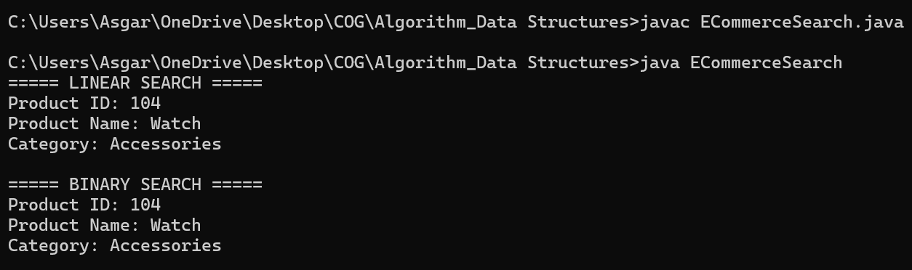

Exercise 7: Financial Forecasting

File: FinancialForecasting.java

public class FinancialForecast {
public static double forecast(double currentValue,
double growthRate,
int years) {
if (years == 0) {
return currentValue;
}
return forecast(currentValue,
growthRate,
years - 1) * (1 + growthRate);
}

public static void main(String[] args) {
double presentValue = 10000;
double growthRate = 0.10; // 10%
int years = 5;
double futureValue =
forecast(presentValue,
growthRate,
years);
System.out.println("Present Value: " + presentValue);
System.out.println("Growth Rate: " + (growthRate * 100) + "%");
System.out.println("Years: " + years);
System.out.println("Future Value: " + futureValue);
}
}
OUTPUT:

